**Lab 2: LED/Phototransistor Optocoupler**

EE 3310L

Spring 2023

**Alex Yeoh**

Cauy Gibson

Submitted to TA: C. Hicks Friday 8:20 AM

Date of Experiment: 01/20/23

Date of Submission 01/27/23

1. **Introduction**

The purpose of this lab is to measure and plot the current transfer characteristics of a phototransistor-type optocoupler and examine its transient behavior [1].

1. **Experimental Methodology**

The first step of the experiment is constructing the circuit following figure 1 below, while ensuring the voltage on the LED side is 0V and the voltage on the phototransistor side is 5V [1].

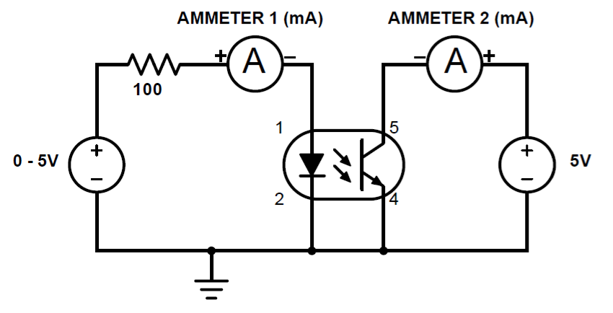

Figure 1. Circuit for exploring the characteristics of optocouplers.

The voltage of the 0 – 5V source is then slowly increased following the LED current column of table 1 below, while recording current as each current threshold is reached [1].

Table 1. Filled table with AMMETER2 measurements for the 4N25 optocoupler.

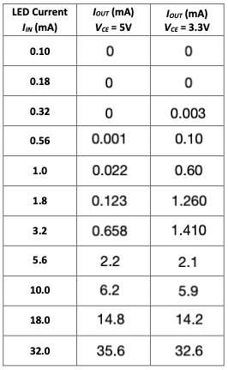

The process above is then repeated for when the constant 5V source is set to a constant 3.3V with the results seen above in table 1 [1].

After this portion of the lab, a new circuit is built following figure 2 below.

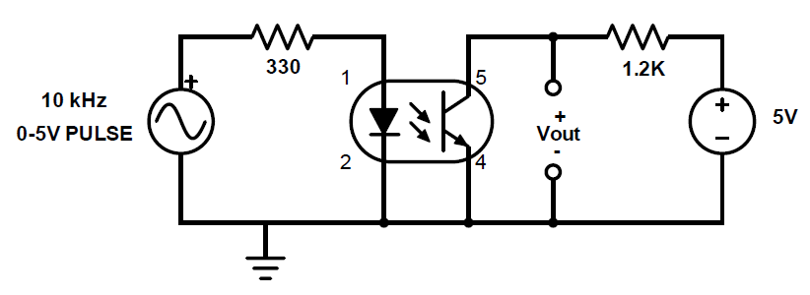

Figure 2: Circuit for testing the pulse response of the 4N25.

The resulting wave is then recorded with an oscilloscope and then exported. This process is then repeated with the 1.2kΩ resistor being replaced with a 470Ω resistor and then repeated once again with the same resistor being replaced with a 2.2kΩ [1].

1. **Results and Description**

The current measurements on the phototransistor side can be seen above in table 1. The oscilloscope measurements can be seen below in figures 3, 4, and 5.

Figure 3: Pulse response of the 4N25 optocoupler with a 1.2kΩ resistor.

Figure 4: Pulse response of the 4N25 optocoupler with a 470Ω resistor.

Figure 5: Pulse response of the 4N25 optocoupler with a 2.2kΩ resistor.

1. **Discussion**

The requested linear and log scaled graphs for table 1 can be seen below in figures 6, 7, 8, and 9.

Figure 6: 4N25 5V source on phototransistor side, linear graph.

Figure 7: 4N25 5V source on phototransistor side, logarithmic graph.

Figure 8: 4N25 3.3V source on phototransistor side, linear graph.

Figure 9: 4N25 3.3V source on phototransistor side, logarithmic graph.

As seen in the 5V graphs, the graphs are not linear. This is also true for the 3.3V graphs, albeit less clear due to a plateau in the middle of its logarithmic graph. A saturation current cannot be determined from the graphs generated from table 1 due to the currents not seeming to have reached saturation.

The graphs can be seen above in figures 3, 4 and 5 above. They have rise times of 1.85µs, 6.133µs, and 23µs for the 1.2kΩ, 470Ω and 2.2kΩ resistors respectively. The 1.2kΩ graph has a rise time that is most similar to the 2µs rise time published, the other two resistor graphs have rise times much greater than the published value.

1. **Summary and Conclusions**

The lab itself is simple and straightforward to complete due to the instructions given, although my lab partner and I did have a minor issue during the second experiment where we accidentally used a sinusoidal wave. This, however, does not mean there was an issue with the lab instructions, we simply missed the one part mentioning the square wave. The lab write-up, however, is a massive burden for a class that does not seem to have the integrated writing attribute listed in the wings express class lookup. This fact feels even more odd due to my previous EE class’s lab only requiring a pre-lab and the given lab sheet filled out to be turned in.

**Reference**

[1] Tritschler, Joe. "LED/Phototransistor Optocoupler." N.p., n.d. Web. 20 Jan 2023.